SNOWFLAKE ARCHITECTURE
Snowflake Editions:
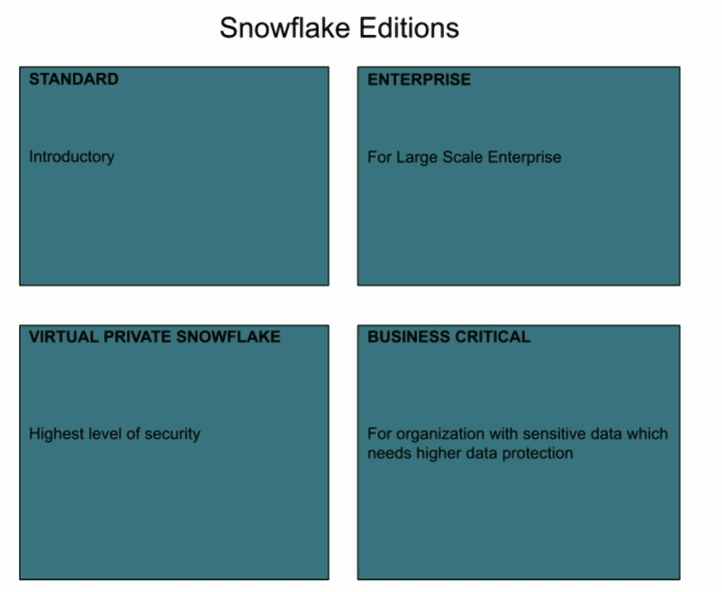
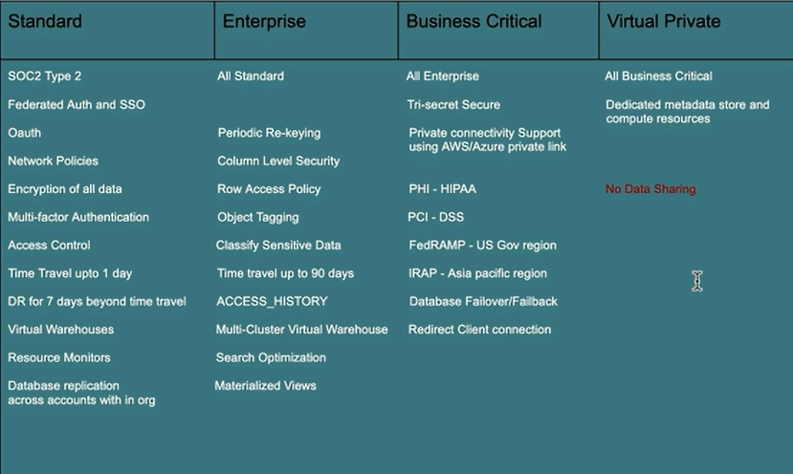
Note: If any terms can’t be understood, I will cover in detail in future posts

Snowflake credits:
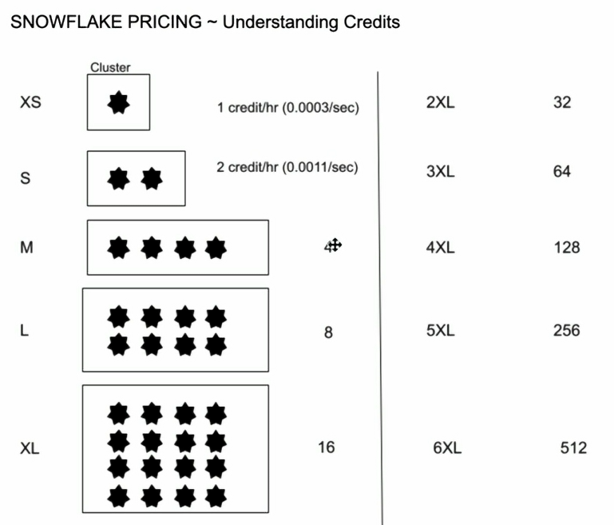

XS – 1 credit/hr = 0.0003 credits/sec
S – 2 credit/hr = 0.0001 credits/sec
And so on
Credits are charged on per second basis on VWH

Credits are charged for user managed virtual warehouses on following:
- Size : the bigger the size of VWH the more the computational power of virtual warehouse, more credits are charged (you had seen above)
We require more size as complicated queries can be executed in faster way
- Number of VWH (multi cluster)
- Time: the more time usage, more credits are charged

Credits are charged for Snowflake managed compute resources on which user don’t have any control whereas on VWH, user has control like creating VWH of size, multi clusters as per he wants
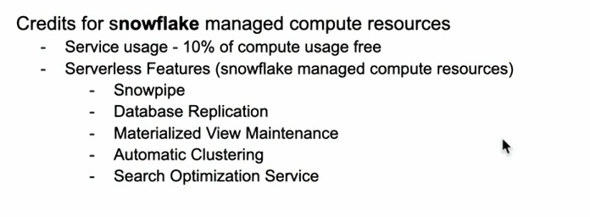
Note: will make u clear the terms and meanings in upcoming posts

Minimum one minute concept:
Start/resume/resize charges one minute
For example, if you have a VWH which ran for 6 seconds and it went down and never came back. Then Snowflake will charge for a minimum of 1 min i.e. 60 sec
Now, let’s say VWH ran for 1 sec and went down. After sometime, it came back again for 30 sec. The total time charged will be 60+60 = 120 sec

Note: once VWH is running with frequent breaks, then for every break point it charges for minimum 1 min even if u don’t use 60 sec of time.
Here are the examples for different cases:
